Name: Mmabatho Matsila
Student number: 2805001615
Date: 23 May 2026

Introduction and objective: The project is about creating a Data Agent by analysing the data, Therefore:
Introduction
This project explores retail sales transactions and customer demographics to better understand how customers interact with products and how sales performance changes over time.
Objective
The objective is to analyse sales and customer data to measure business performance, identify top-performing products and customer groups, and provide meaningful insights from the dataset.

Dataset description - dataset contains retail transaction records and customer demographic information used to analyse sales performance, customer purchasing behaviour, and product trends within a retail business environment.

10 STEPS ROAD MAP OF MY DATASET:
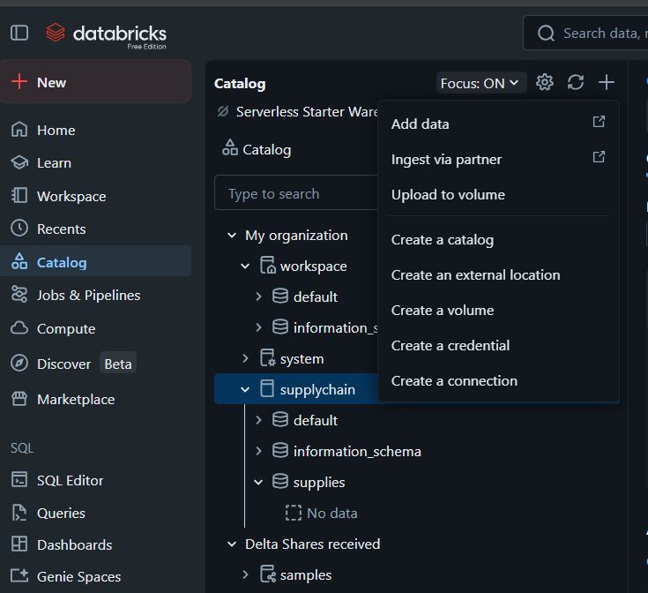
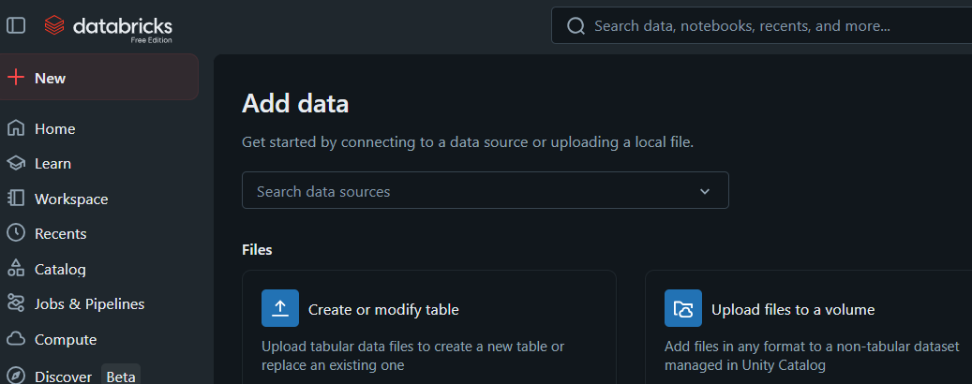
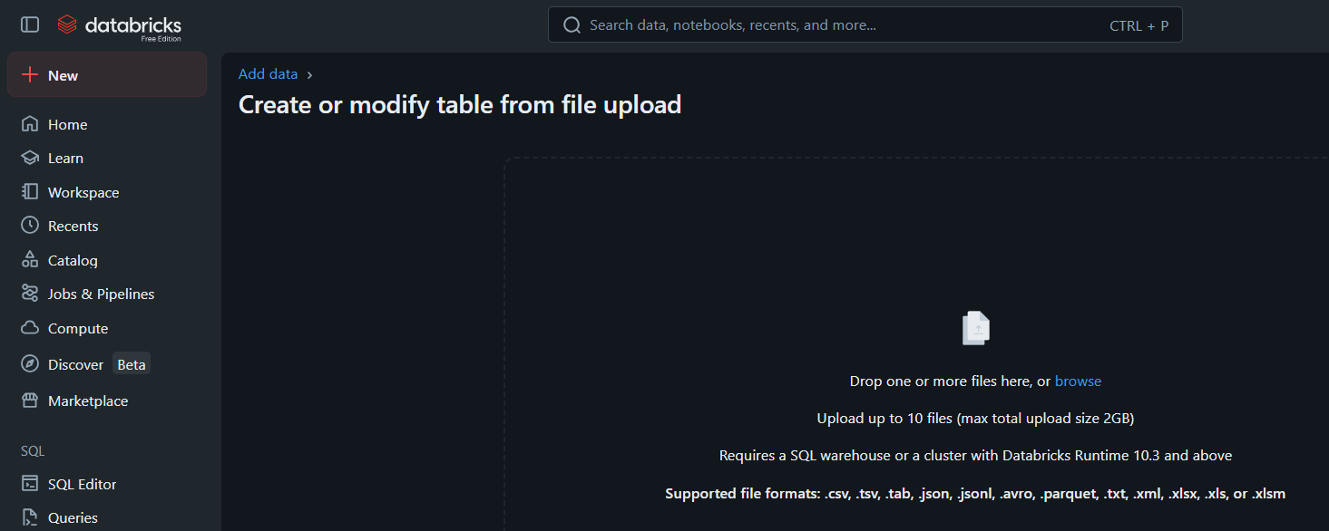

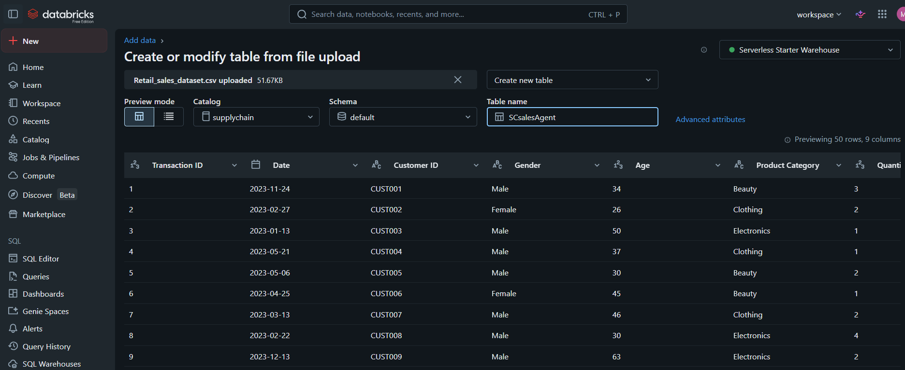

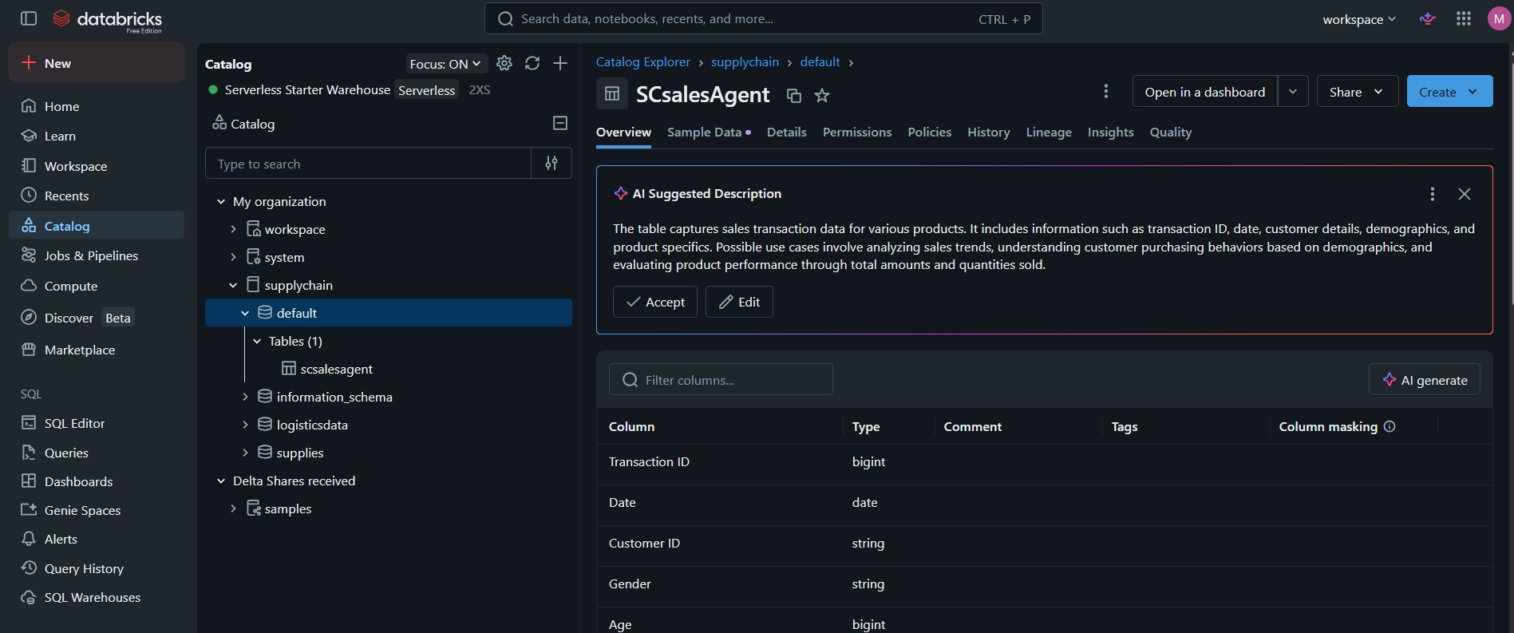

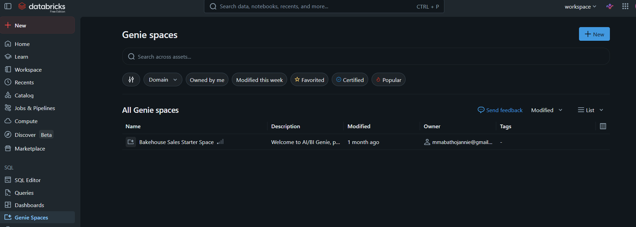

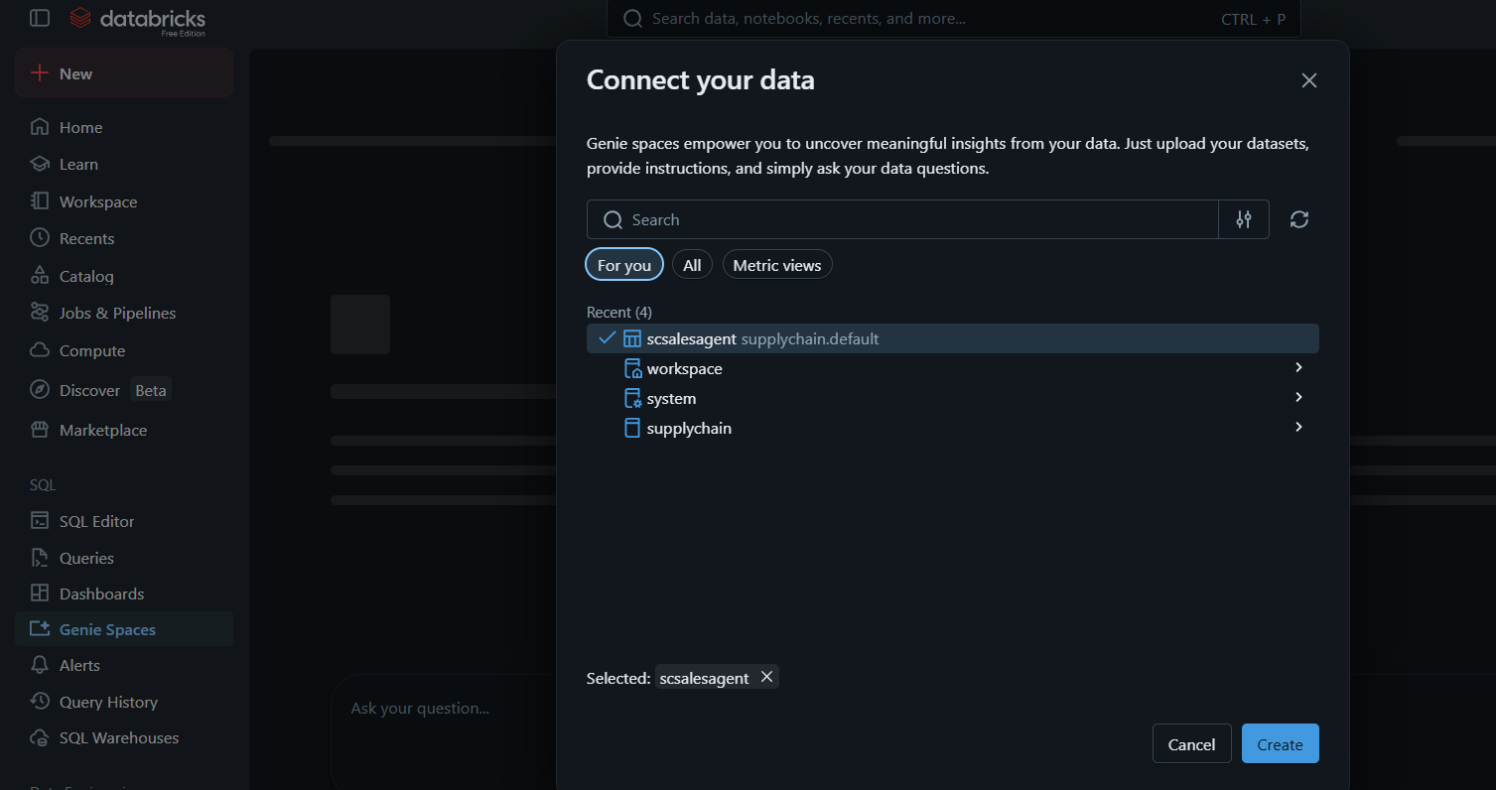

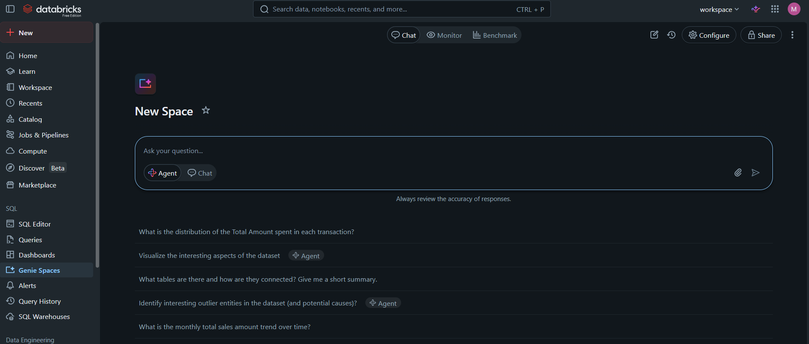

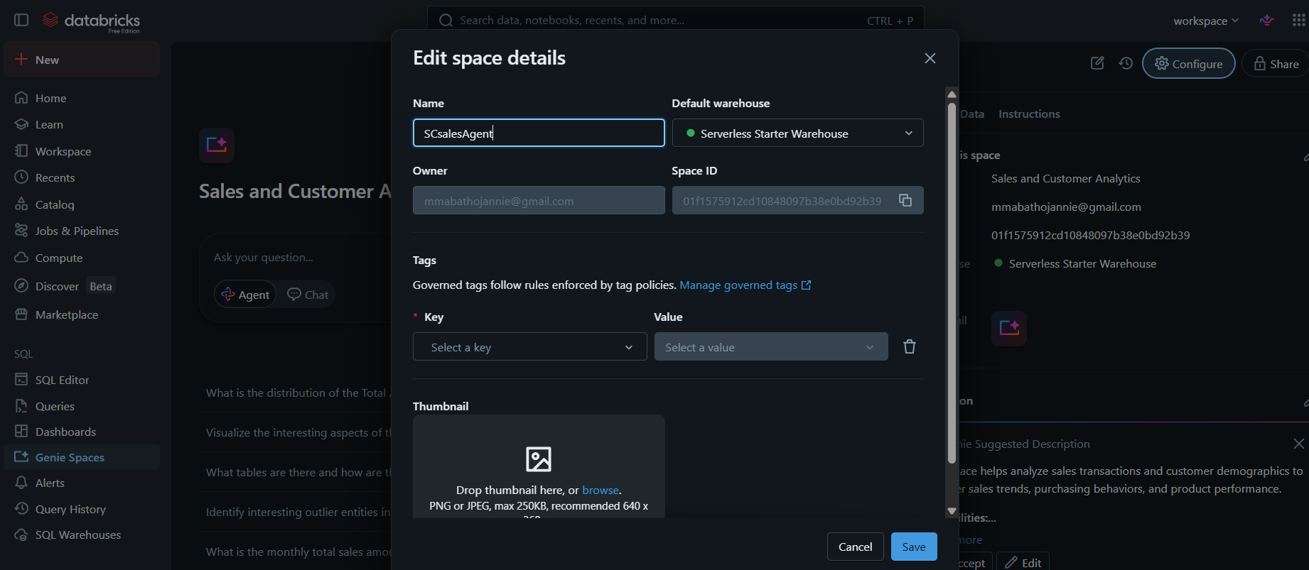

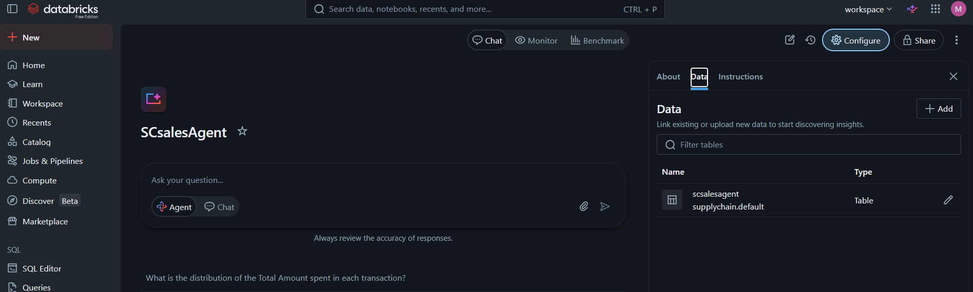

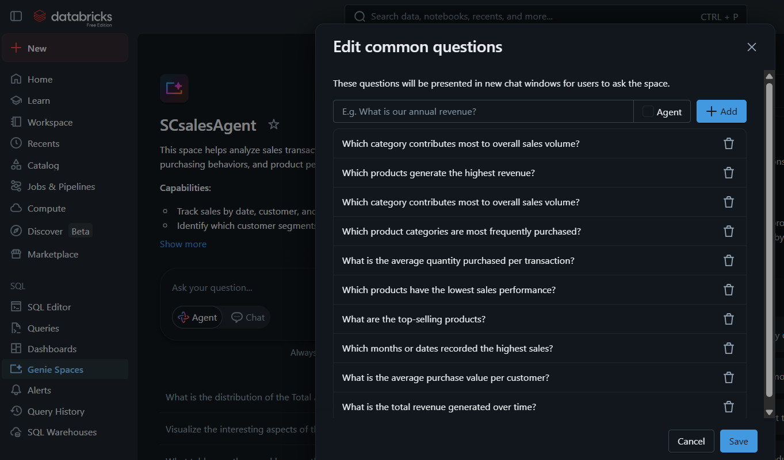

STEP 4 – Required screenshots

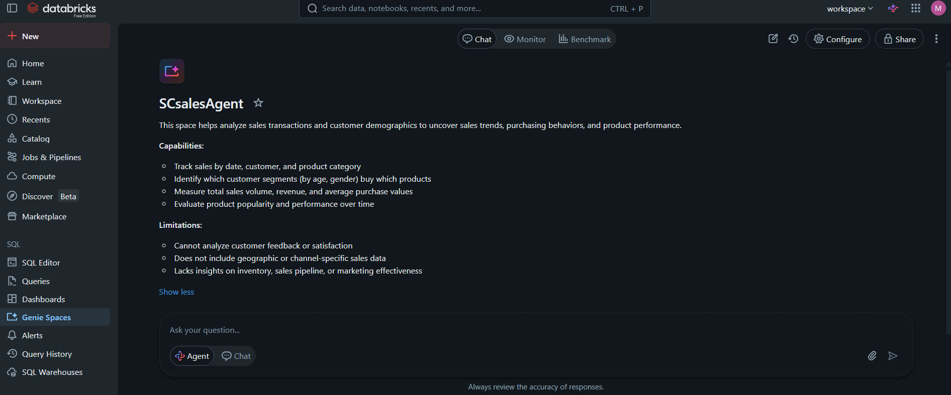

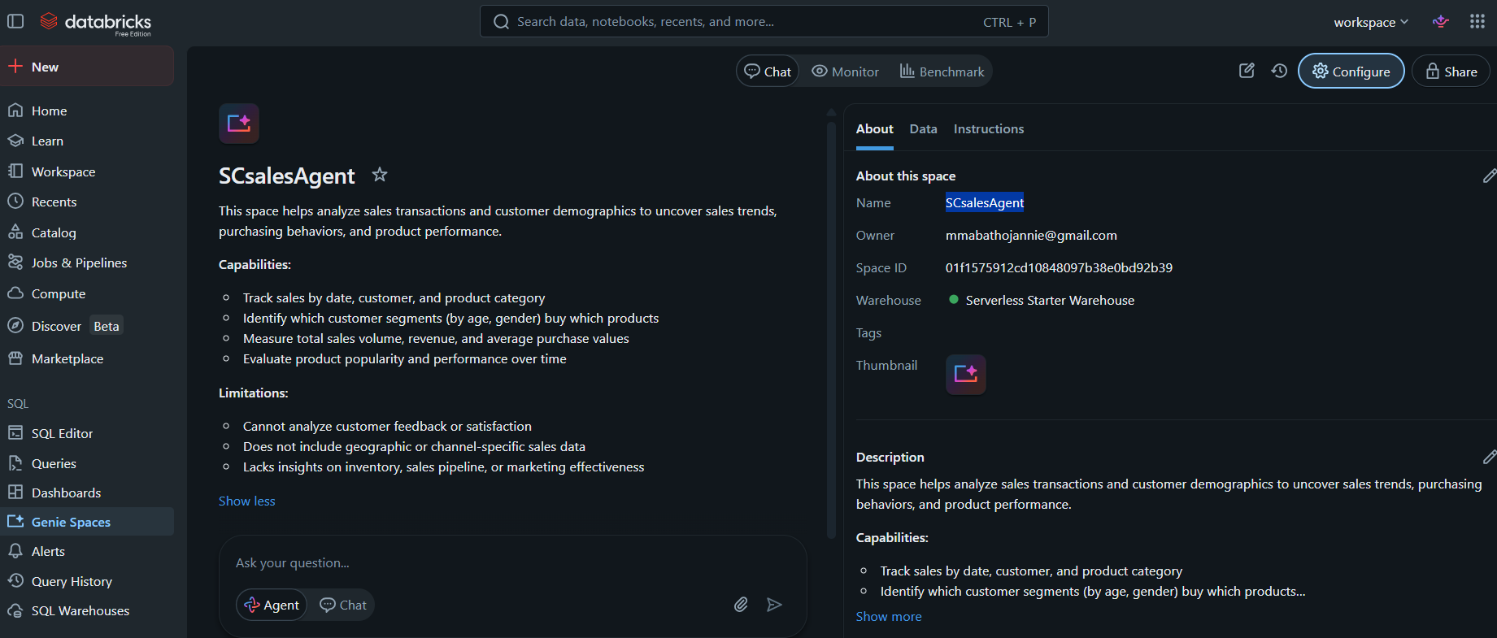

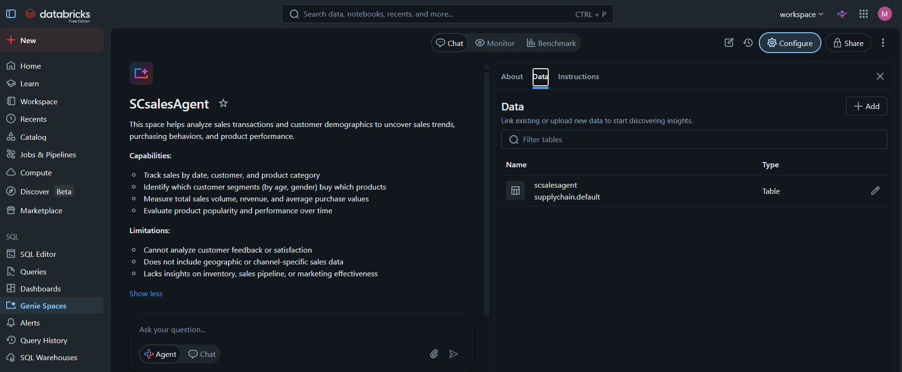

STEP 5: Write your own instructions
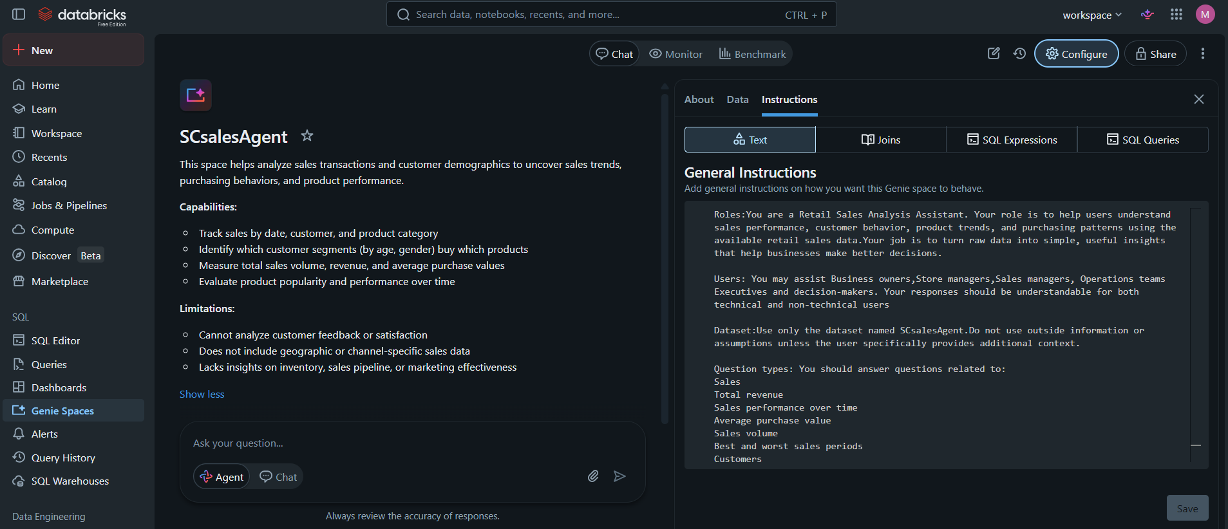

STEP 6: Test with 10 questions
- 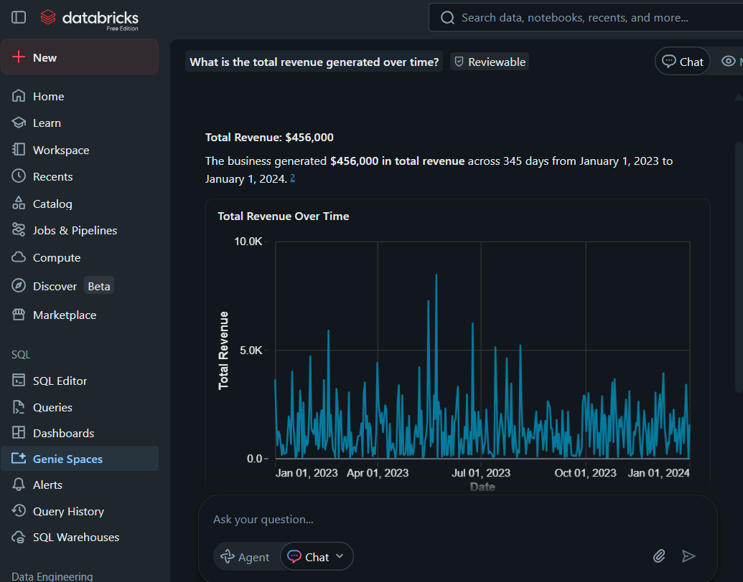

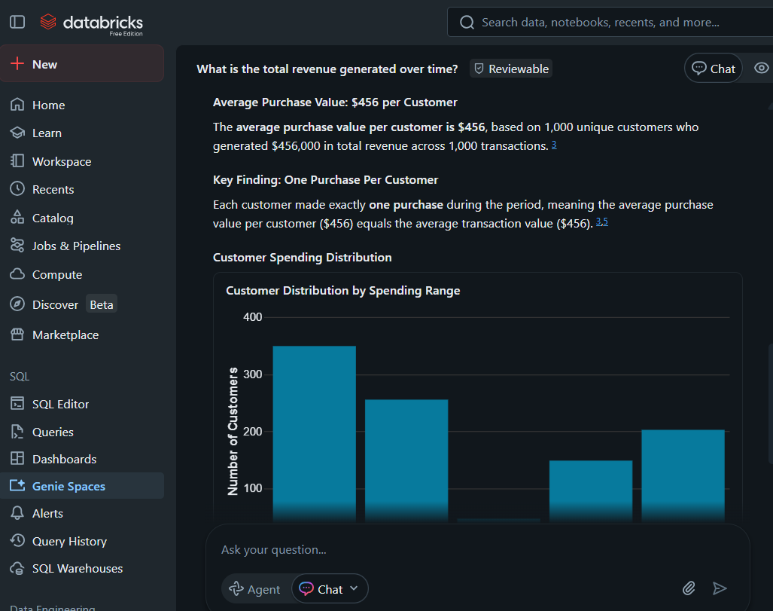

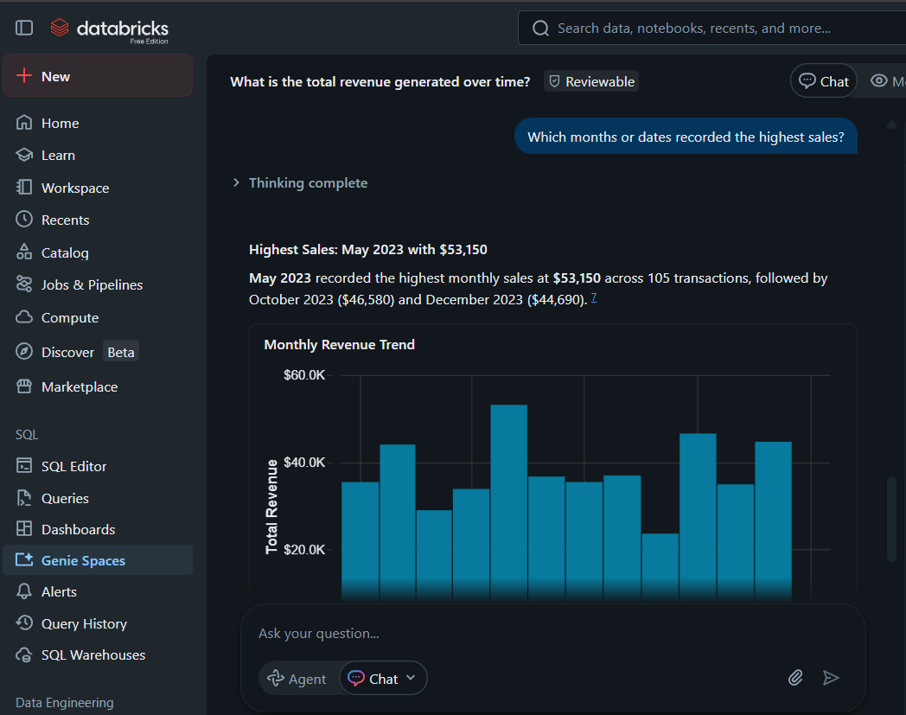

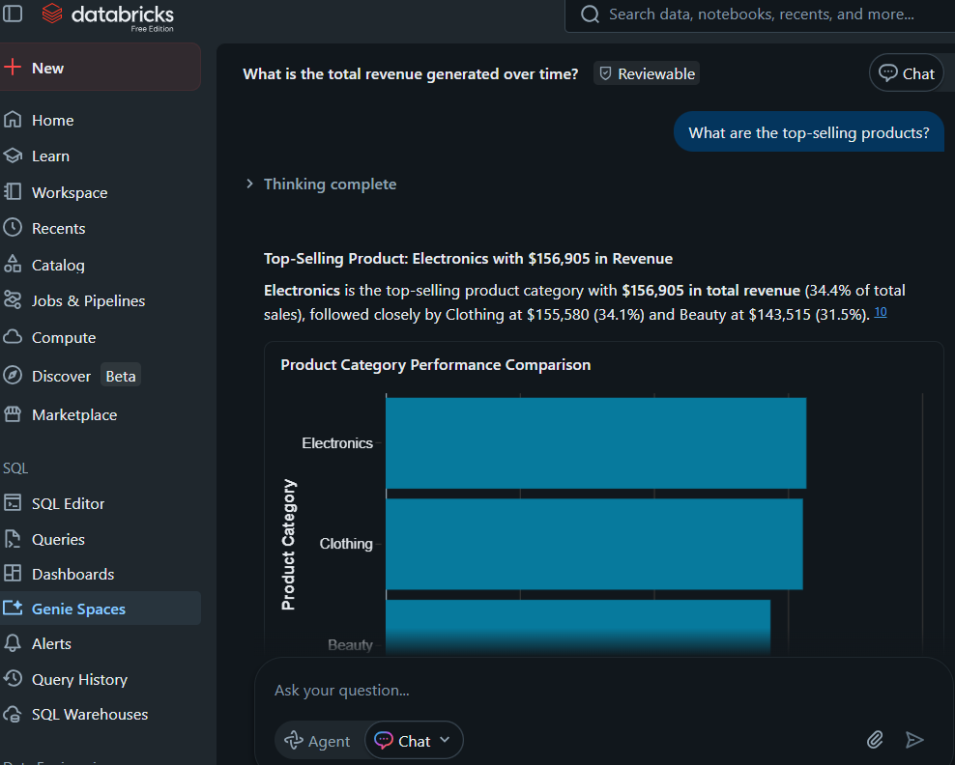

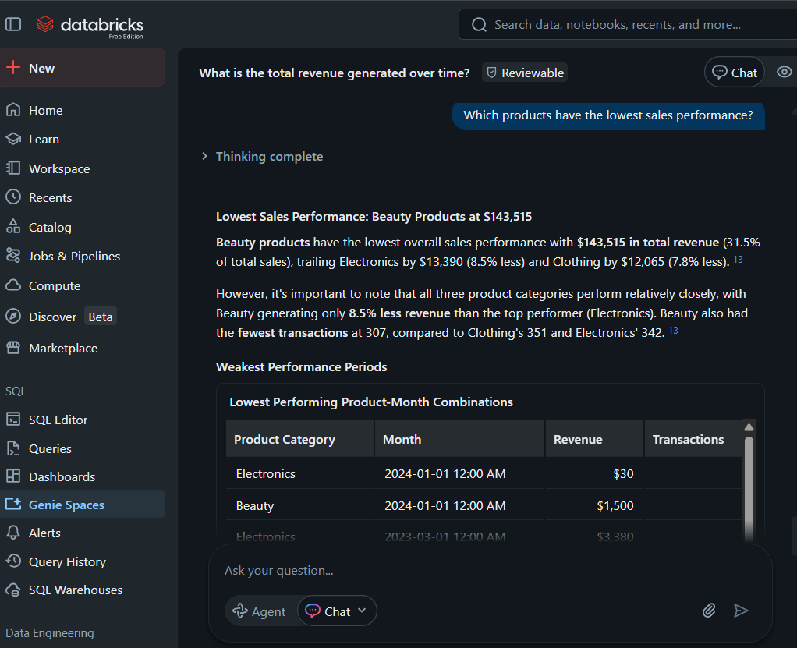

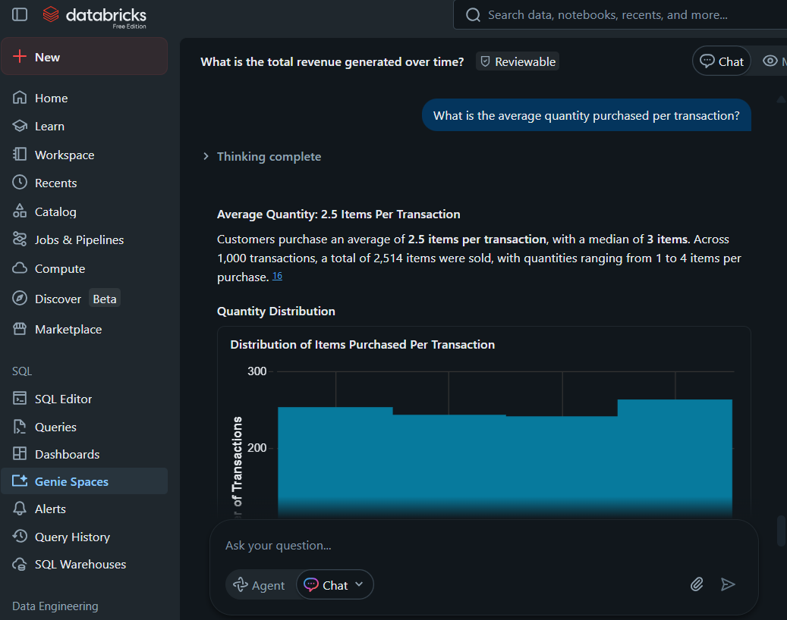

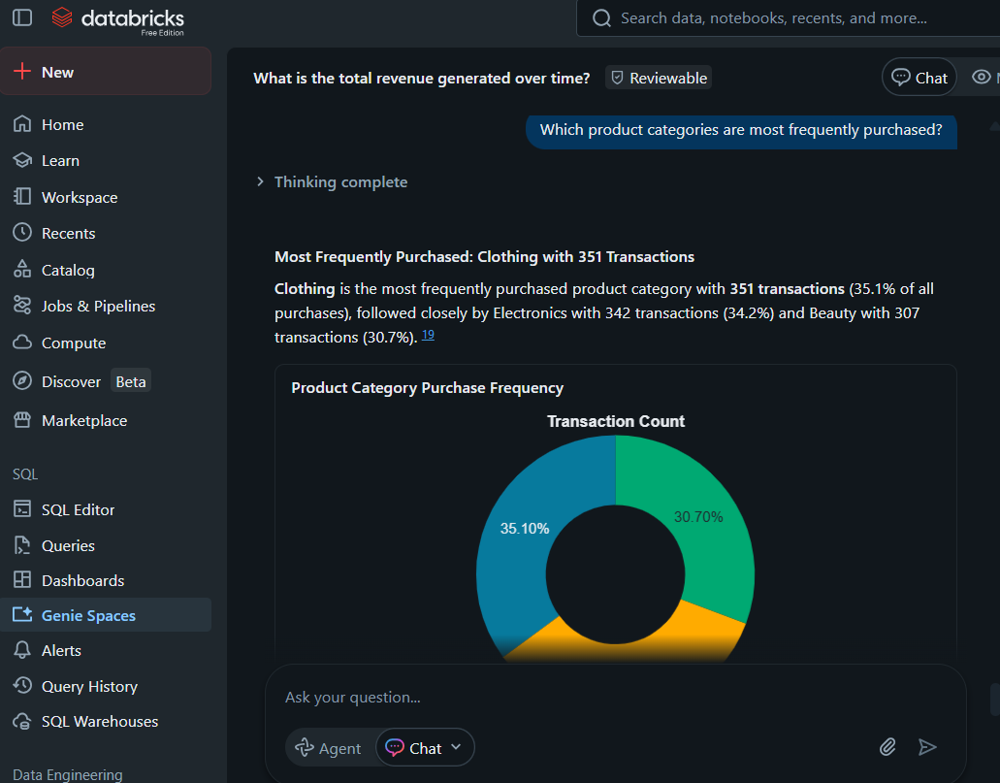

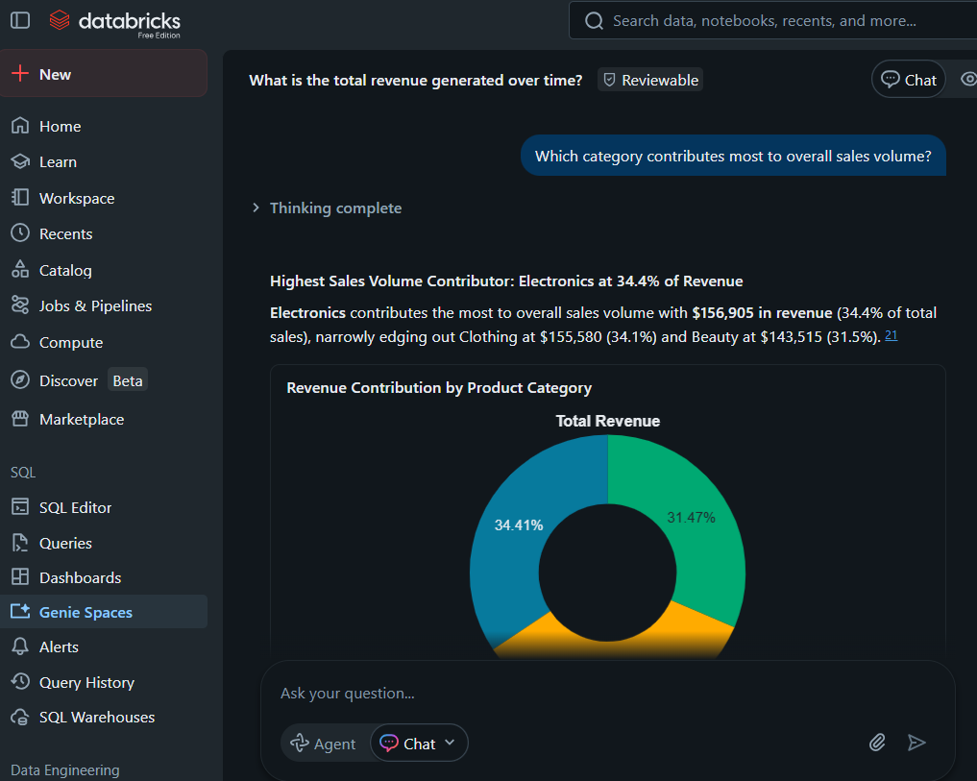

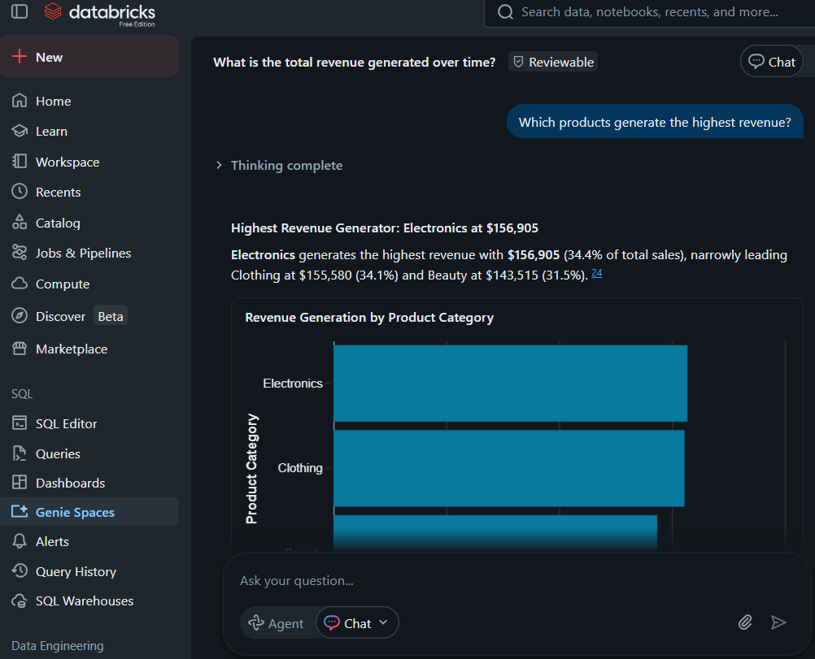

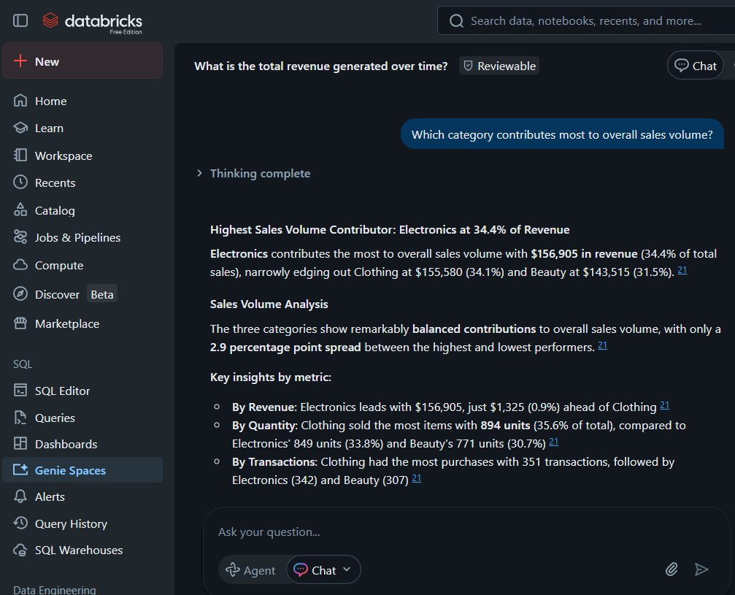

STEP 7: Validate the answer

Original question | Original answer | Validated answer to the same question | Validated answer | Explanation
- Which category contributes most to overall sales volume? | Highest Sales Volume Contributor: Electronics at 34.4% of Revenue | Which product category generates the highest overall sales volume? | Highest Sales Volume: Electronics at 34.4% of Revenue | Based on the original and validated questions, the answer is correct as it all shows the highest contriber as Electronics with 34.4%
- Which products have the lowest sales performance? | Lowest Sales Performance: Beauty Products at $143,515 | Which products generated the lowest sales revenue during the selected period? | Lowest Sales Revenue: Beauty Products at $143,515 | Based on the original and validated questions, the answer is correct as it all shows the Lowest performance as Beauty producrs with $143.515
- What is the average quantity purchased per transaction? | Average Quantity: 2.5 Items Per Transaction  Customers purchase an average of 2.5 items per transaction, with a median of 3 items. Across 1,000 transactions, a total of 2,514 items were sold, with quantities ranging from 1 to 4 items per purchase. 16 | What is the average quantity of products purchased per transaction? | Average Quantity: 2.5 Items Per Transaction  Customers purchase an average of 2.5 items per transaction, with a median of 3 items. Across 1,000 transactions, a total of 2,514 items were sold, with quantities ranging from 1 to 4 items per purchase. | Based on the original and validated questions, the answer is correct as it all shows the average quantity as 2.5 per transaction.

KEY INSIGHT
Sales were highest in a few key product categories.
Younger customers contributed a large portion of purchases.
Certain months showed stronger sales performance than others.
Average transaction values highlighted customer spending patterns.

BUSINESS RECOMMANDATIONS
Focus more on the top-selling product categories.
Create promotions targeting the highest spending customer groups.
Monitor low-performing products and improve marketing strategies.
Use sales trends to plan future business decisions.

CONCLUSION
This project helped uncover useful business insights from retail sales data. The main challenge was handling questions where data was missing or limited. Future improvements could include adding more business and customer information for deeper analysis.

